Servo Motor Sweep

Sweeps the shaft of a RC [servo motor](http://en.wikipedia.org/wiki/Servo_motor#RC_servos) back and forth across 180 degrees.

This example makes use of the Arduino [servo library](https://www.arduino.cc/en/Reference/Servo).

Hardware Required

* Arduino or Genuino Board
* Servo Motor
* hook-up wires

Circuit

Servo motors have three wires: power, ground, and signal. The power wire is typically red, and should be connected to the 5V pin on the Arduino or Genuino board. The ground wire is typically black or brown and should be connected to a ground pin on the board. The signal pin is typically yellow, orange or white and should be connected to pin 9 on the board.

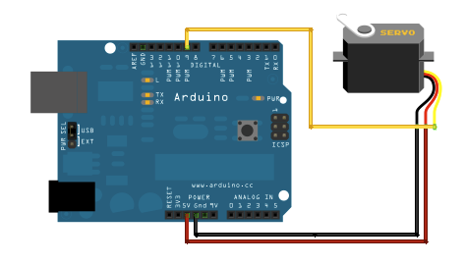

Schematic

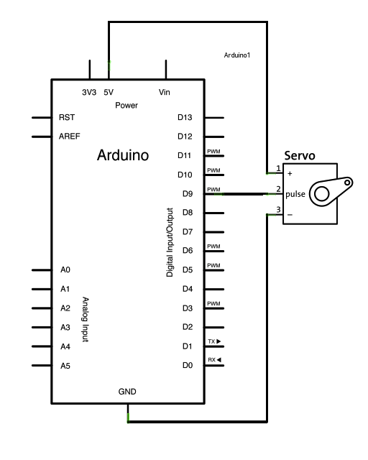

Code

#include <Servo.h>  
  
Servo myservo;  *// create servo object to control a servo*  
*// twelve servo objects can be created on most boards*  
  
int pos = 0;    *// variable to store the servo position*  
  
void **setup**() {  
  myservo.attach(9);  *// attaches the servo on pin 9 to the servo object*  
}  
  
void **loop**() {  
  for (pos = 0; pos <= 180; pos += 1) { *// goes from 0 degrees to 180 degrees*  
    *// in steps of 1 degree*  
    myservo.write(pos);              *// tell servo to go to position in variable 'pos'*  
    delay(15);                       *// waits 15ms for the servo to reach the position*  
  }  
  for (pos = 180; pos >= 0; pos -= 1) { *// goes from 180 degrees to 0 degrees*  
    myservo.write(pos);              *// tell servo to go to position in variable 'pos'*  
    delay(15);                       *// waits 15ms for the servo to reach the position*  
  }  
}

|  |  |  |  |  |
| --- | --- | --- | --- | --- |
| Your full name | Tel. | Email | Group | Su23 |
| Nguyễn Xuân Trung | 0944353601 | [Trungnxqe170172@fpt.edu.vn](mailto:Trungnxqe170172@fpt.edu.vn) | 2 – SE17B02 |  |
| Đoàn Nguyễn Huyền Trang | 0344468198 | trangdnhqe170154@fpt.edu.vn |  |  |
| Phan Phương Sinh |  |  |  |  |
| Nguyễn Đồng Lợi |  |  |  |  |
| Đường Mỹ Hà | 0901130650 | HaDMQE170046@fpt.edu.vn |  |  |
| Screen shot:    https://www.tinkercad.com/things/j5n8zuROLIY-13aservomotorsweep/editel?sharecode=rVPaZLD_jjucuOkgGdgL4nispva_VDS1SfWbcyJtPeA | | | | |
| How it works?  The Servo.h library is used to control the servo motor. | | | | |